**TABLE OF CONTENTS**

**ABSTRACT** 1

**CAHPTER 1** 2-4

1.1 Introduction 2

* Purpose 3
* Scope 3
* Features 4

**CHAPTER 2. SYSTEM ANALYSIS** 5-6

2.1 Hardware Requirements 5

2.2 Software Requirements 6

**CHAPTER 3** 7-8

3.1 Language Used 7

**CHAPTER 4. SYSTEM DESIGN & SPECIFICATION** 9-22

4.1 FLOW CHART 9

4.2 ER DIAGRAM 10

4.3 SCREEN SHOTS 11-20

**CHAPTER 5. CODING** 21-27

**CHATER 6. TESTING** 28-29

**CONCLUSION** 30

**LIMITATION** 31

**REFERENCE** 32

**.**

**ABSTRACT**

The online book store” BOOKMARK” emerges as a transformative force in the realm of online bookstores, presenting an innovative approach to democratizing access to knowledge. With an expansive and thoughtfully curated collection spanning diverse genres, the platform ensures an intuitive and user-friendly interface, allowing seamless exploration for users. What distinguishes The BOOKMARK is its unwavering commitment to dismantling payment barriers, providing users the unique opportunity to download books without financial constraints. Beyond being a repository of literature, the project fosters a vibrant community by encouraging discussions, facilitating book recommendations, and connecting readers with shared literary interests. Authors are integral to this ecosystem, benefiting from a voluntary contribution model that enables users to directly support their work. The platform is designed for cross-platform accessibility, ensuring readers can enjoy their chosen titles anytime, anywhere. Additionally, The BOOKMARK goes beyond recreational reading, incorporating an educational facet with a dedicated section for academic resources, positioning itself as a valuable tool for intellectual growth. In essence, The BOOKMARK endeavors to redefine the online book store paradigm, championing inclusivity, community, and a shared passion for literature. This project aspires to unite a global community of readers under the banner of unrestricted access to knowledge, marking a significant stride in democratizing the wealth of human insights and narratives encapsulated within the pages of countless books.

**CHAPTER – 1**

**1.1 INTRODUCTION**

In the digital epoch, "The BOOKMARK" emerges as a pioneering force in the landscape of online literature, transcending conventional norms to redefine the very essence of bookstores in the digital era. This avant-garde online book platform goes beyond the conventional boundaries of literary repositories, presenting a revolutionary model where access to knowledge is unshackled from financial constraints. With a meticulously curated collection spanning a multitude of genres, The BOOKMARK prioritizes not only the diversity of its offerings but also a seamless, user-friendly interface, ensuring that the exploration of literature becomes an intuitive and enriching experience. What sets this platform apart is its unwavering commitment to democratizing literature—readers can download books without the encumbrance of financial transactions, representing a paradigm shift in the accessibility of literary works. However, The BOOKMARK is not merely a digital library; it is a dynamic community hub that fosters connections among readers. By encouraging discussions, facilitating book recommendations, and providing a space for like-minded individuals to converge, the platform becomes a vibrant ecosystem where the love for literature is not only discovered but also shared and celebrated. Authors are integral to this ecosystem, finding support through a distinctive voluntary contribution model, enabling readers to directly contribute to the creators whose works resonate with them. Designed for cross-platform accessibility, The BOOKMARK ensures that the joy of reading is not confined to a specific device or location, providing readers the freedom to immerse themselves in their favorite books at their convenience. Moreover, transcending traditional boundaries, the platform incorporates an educational dimension with a dedicated section for academic resources, positioning itself as a versatile tool for both leisurely reading and intellectual growth. In essence, The BOOKMARK is not just a platform; it's a transformative movement, championing inclusivity, community, and a shared passion for literature, ushering in a new era in the democratization of knowledge and the celebration of the written word.

**1.1.1 PURPOSE**

The fundamental purpose of "The BOOKMARK" is to revolutionize the landscape of online literature by championing unrestricted access to knowledge. Rooted in the belief that knowledge should be a universal right, the project aims to democratize the literary experience by eliminating financial barriers to accessing books. The platform serves as a dynamic bridge between readers and an extensive, thoughtfully curated collection spanning diverse genres, fostering a global community of individuals united by their shared love for literature. Beyond being a digital library, The BOOKMARK aspires to create an interactive space where readers can engage in discussions, share recommendations, and connect with like-minded enthusiasts. By incorporating a voluntary contribution model, the project not only supports authors but also encourages a culture of appreciation for the creative process. With cross-platform accessibility, The BOOKMARK ensures that the joy of reading is not confined to specific devices or locations, promoting a flexible and immersive reading experience. Additionally, the project integrates an educational dimension, offering a dedicated section for academic resources, positioning itself as a versatile tool for both leisurely reading and intellectual growth. In essence, the overarching purpose of The BOOKMARK is to redefine the online book store paradigm, emphasizing inclusivity, community, and a shared passion for literature, thereby contributing to the democratization of knowledge and fostering a global culture of reading and learning.

**1.1.2 SCOPE**

"The BOOKMARK" presents a transformative scope in the digital literary sphere, offering unrestricted access to diverse genres without financial barriers. With a unique emphasis on community engagement and author support, it has the potential to become a global hub for collaborative literature. The project's versatility extends beyond recreational reading, positioning it as an invaluable resource for academic pursuits. In its commitment to democratizing knowledge, The BOOKMARK emerges as a dynamic force poised to redefine the landscape of online bookstores, catering to a broad spectrum of readers and fostering a culture of accessible and collaborative learning.

**1.1.3 FEATURES**

**1. Extensive Book Collection:**

The BOOKMARK offers a diverse library, carefully curated to span classic and contemporary genres, ensuring a fulfilling reading experience for a wide audience.

**2. User-Friendly Interface:**

Prioritizing simplicity, The BOOKMARK provides an intuitive interface for effortless navigation, making literary exploration straightforward and enjoyable for users of all technological backgrounds.

**3. Community Engagement:**

Beyond a book repository, The BOOKMARK fosters a vibrant community. Users actively participate in discussions, share recommendations, and connect, creating a dynamic ecosystem around the shared passion for literature.

**4. Educational Initiatives:**

The BOOKMARK goes beyond recreational reading, incorporating educational features and providing a dedicated space for academic resources, making it a valuable tool for both leisurely reading and intellectual growth.

**5. No Payment Barrier:**

The unique feature of The BOOKMARK is its absence of payment barriers, enabling users to download books without financial constraints, aligning with the project's mission to democratize knowledge and promote inclusivity in literature access.

**CHAPTER – 2**

**SYSTEM ANALYSIS**

**2.1 HARDWARE REQUIREMENT**

**MOBILE PHONE:**

We need android phone or ios based phone to run android apps which we are building

there is no specific requirements of mobile phone to run android apps.

Min android version supported – 6

Min RAM - 1 GB

**LAPTOP/PC :**

**Operating System Version –**

Microsoft Windows 7/8/10 /11 (32- or 64-bit)

The Android Emulator only supports 64-bit Windows**.**

**RAM –**

4 GB RAM minimum; 8 GB RAM recommended.

**2.2 SOFTWARE REQUIREMENT**

1. **Web Server:**

- A web server, such as Apache to handle incoming HTTP requests and serve the web application to users.

**2.VS CODE :**

Visual Studio Code is an editor that favors simplicity over having an endless assortment of bells and whistles. Most of the functionality is exposed by typing in the thing you need into the top search bar. Everything you would expect to be there is there: debugging, breakpoints, etc.

**3. Front-End Technologies:**

- HTML, CSS, and JavaScript for creating the user interface and handling client-side interactions.

**4. Database Management System (DBMS):**

- A relational database management system (RDBMS) like MySQL,and PHP for storing and retrieving data efficiently.

**CHAPTER – 3**

**3.1 LANGUAGE USED** / Emulator

Mob Mobile Phone-> The Android Emulator s

**HTML:**

**1.Book Display:**

Use HTML to structure the content of your web pages. Create containers for displaying book details such as title, author, and cover image.

**2.Download Links:**

Integrate HTML links or buttons within the book containers, each representing a download option for the respective book.

**3.Download Management:**

Employing HTML, we can streamline the download process using hyperlinks equipped with the ‘download’ attribute. When a user clicks on such a link, the browser takes over the download process. This method ensures users have direct access to resources, demonstrating the effectiveness of HTML in managing user interactions. For more complex tasks, such as user authentication, server-side languages like PHP are typically utilized. This approach underscores the importance of user-friendly design in boosting user engagement. Furthermore, it highlights the seamless integration of client-side and server-side technologies to deliver a robust and efficient web application.

**CSS:**

**1.Styling:**

Apply CSS styles to enhance the visual appeal of your web pages. Style the book containers, fonts, and other elements to create an aesthetically pleasing and cohesive design.

**JavaScript:**

The LoginPage is brought to life with the power of JavaScript, enabling a seamless transition from the login to the registration page. This dynamic shift not only enhances user experience but also adds a visually appealing element to the interface. The vibrant display captures the user’s attention, making the interaction with the website more engaging and enjoyable.

**PHP:**

**1.Server-Side Logic:**

Leveraging PHP for server-side operations, we can maintain a repository of book details on the server, which could be structured as a database or flat files. When a user navigates to a page, PHP can be employed to dynamically construct the HTML containing the specifics of the books. This approach not only showcases the power of PHP in creating dynamic web content but also emphasizes the importance of efficient data storage and retrieval systems. The dynamic generation of HTML pages enhances the responsiveness of the website, providing users with real-time access to the stored book details, thereby improving the overall user experience.

**2.Security Measures:**

Incorporate security protocols in PHP to guarantee a secure download process. This could include verifying user permissions, validating user input, and safeguarding against potential security threats. This approach not only ensures the integrity of the download process but also enhances user trust in the system. It underscores the importance of robust security measures in maintaining a secure web environment. Furthermore, it demonstrates how PHP can be effectively used to implement complex security protocols, thereby contributing to the overall reliability and safety of the web application. Lastly, these measures can help in preventing unauthorized access and potential data breaches, thereby protecting both the user and the system.

you can test your application on a variety of devices an

**CHAPTER – 4**

## **SYSTEM DESIGN & SPECIFICATION**

**4.1 FLOW CHART**

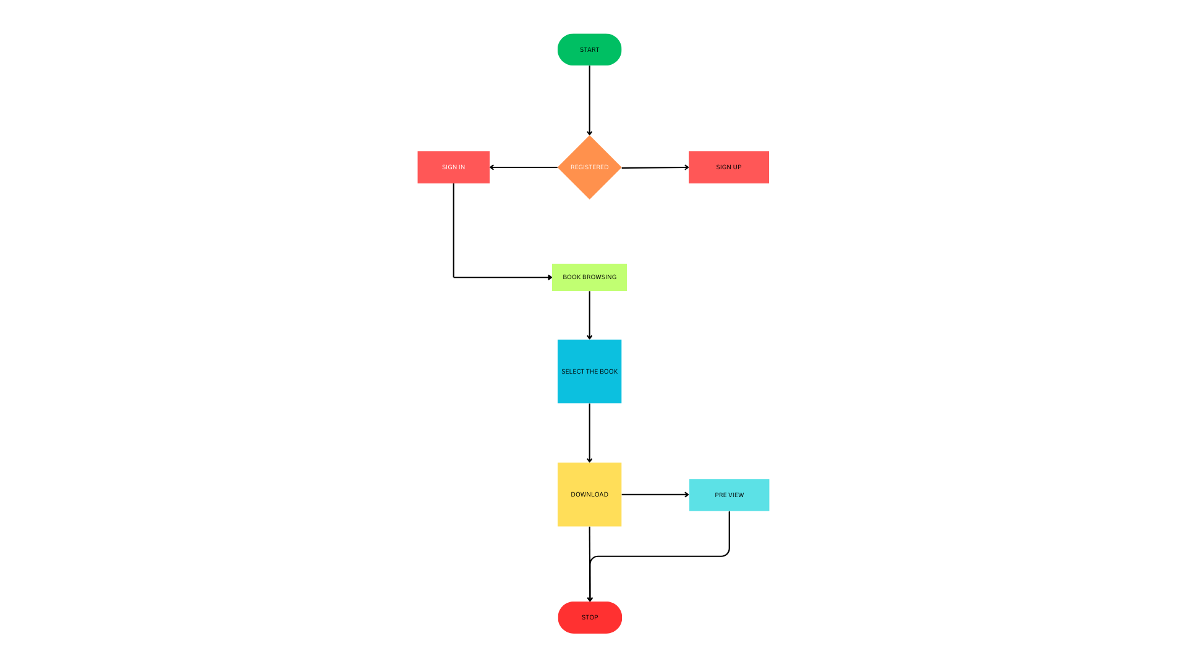

**4.2** **ER DIAGRAM (LIBRARY)**

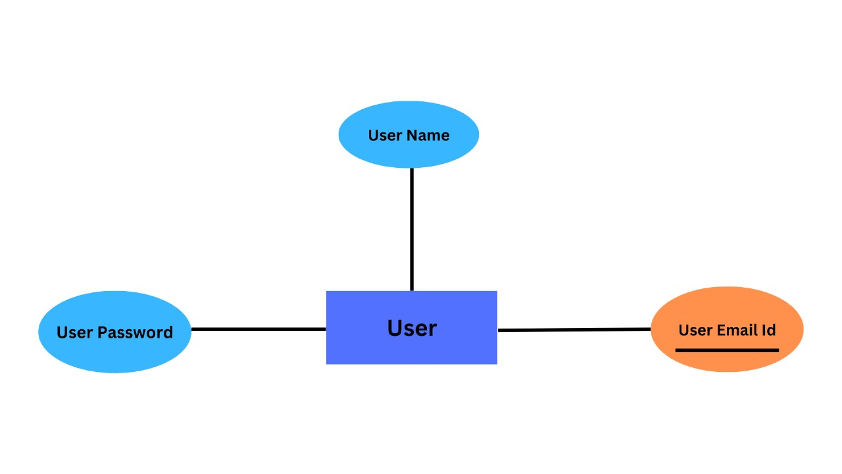

* 1. **SCREEN SHOTS**

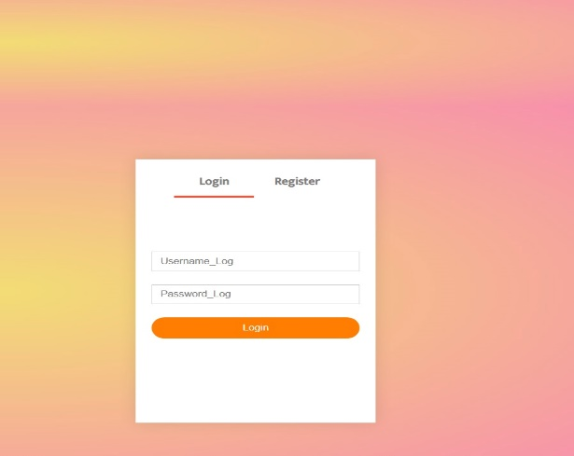

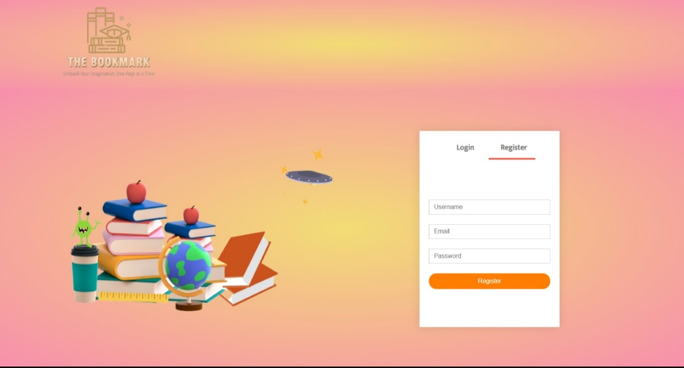

|  |  |
| --- | --- |
| **Fig.1 Fig.2**  **Registration page Login Page**    **Fig.3**  **Faild login**    **Fig.4**  **Main Front page**    **Fig.5**  **Featured Books** |  |

**Fig.6**

**Latest Books**

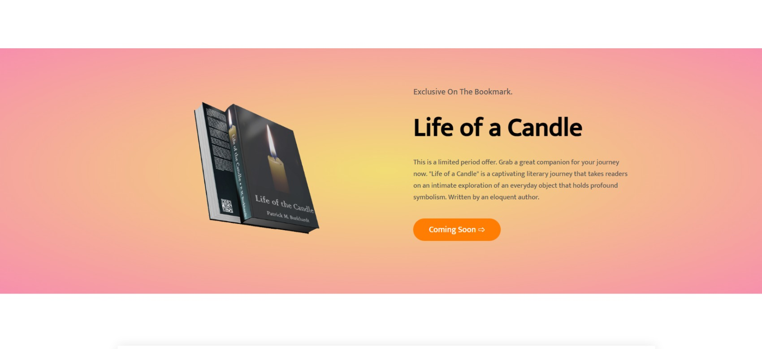

**Fig.7**

**Exclusive Product**

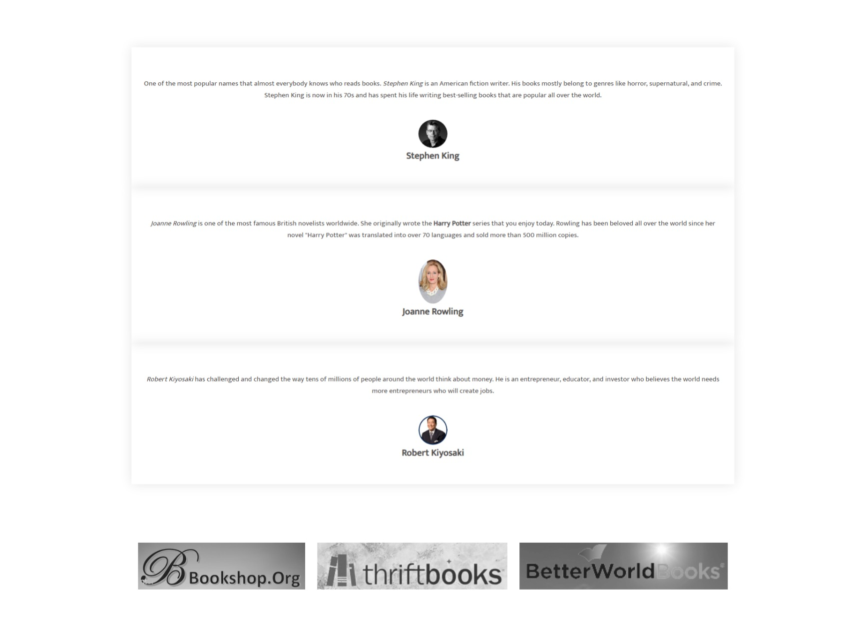

**Fig.8**

**Author details**

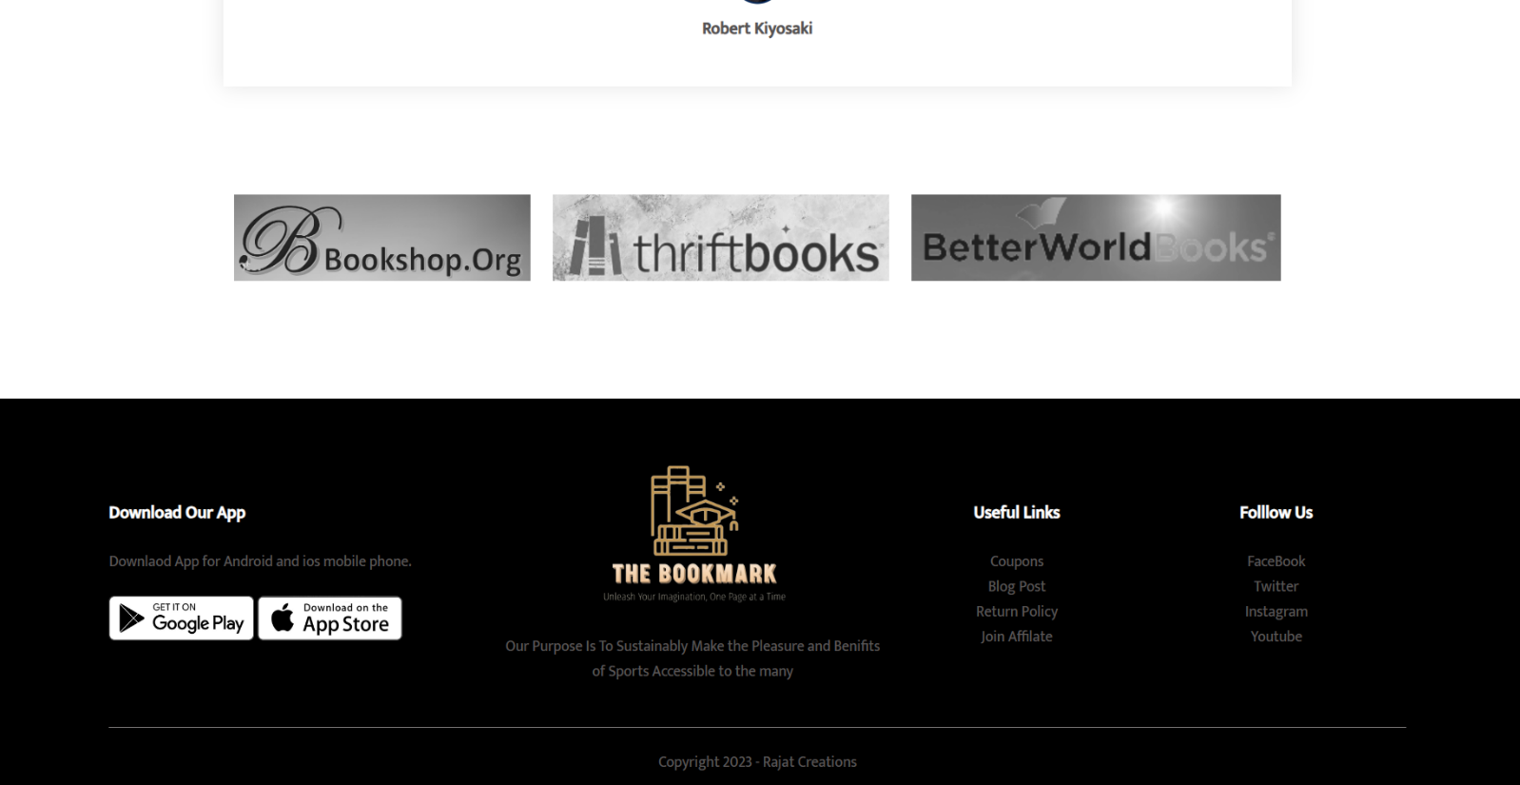

**Fig.9**

**Footer section**

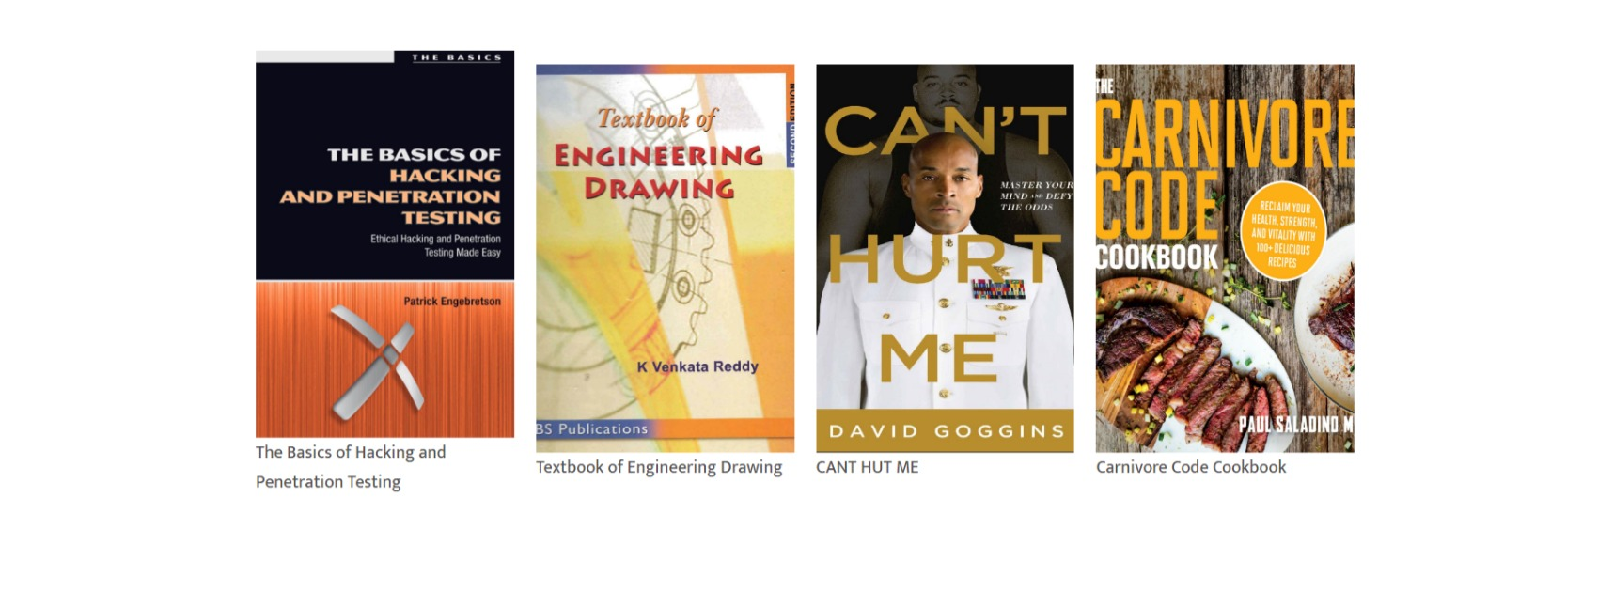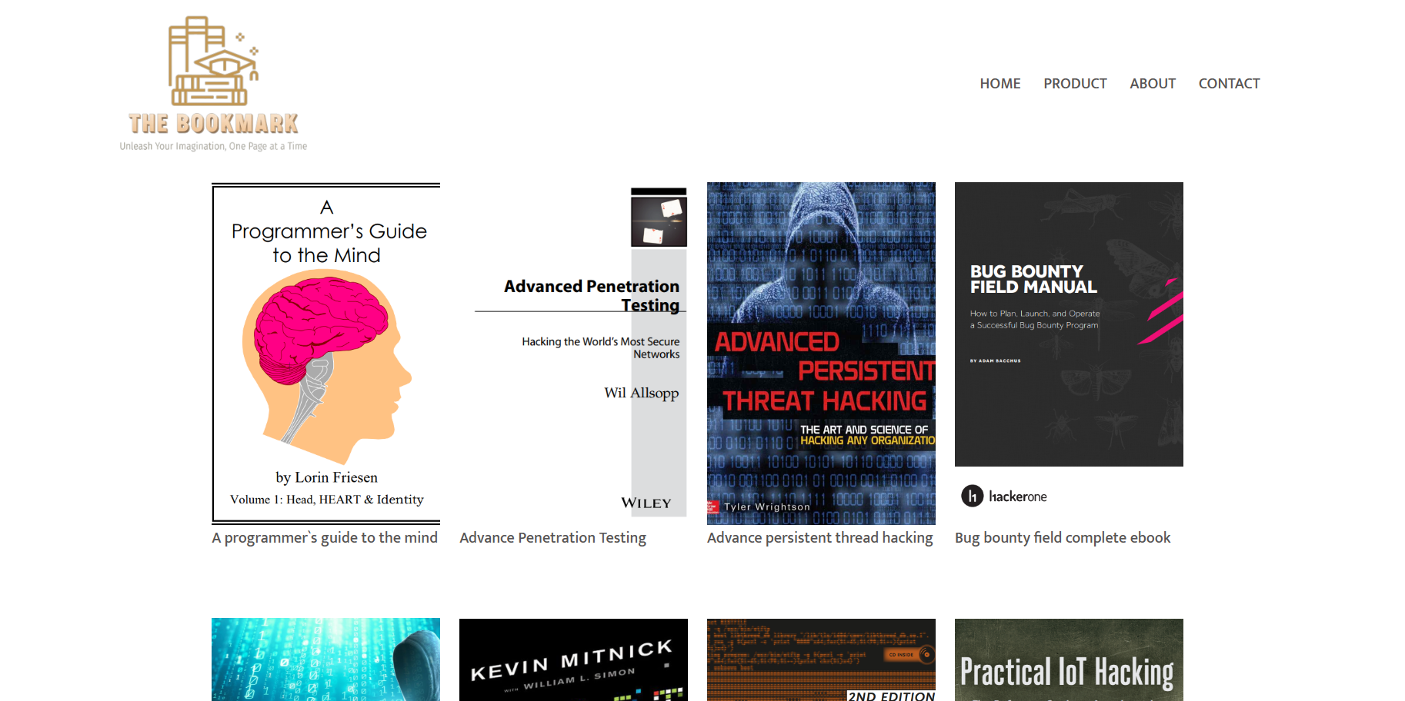

**Fig.7**

**List of books**

**Fig.7**

**List of books**

**Fig.10**

**List of books**

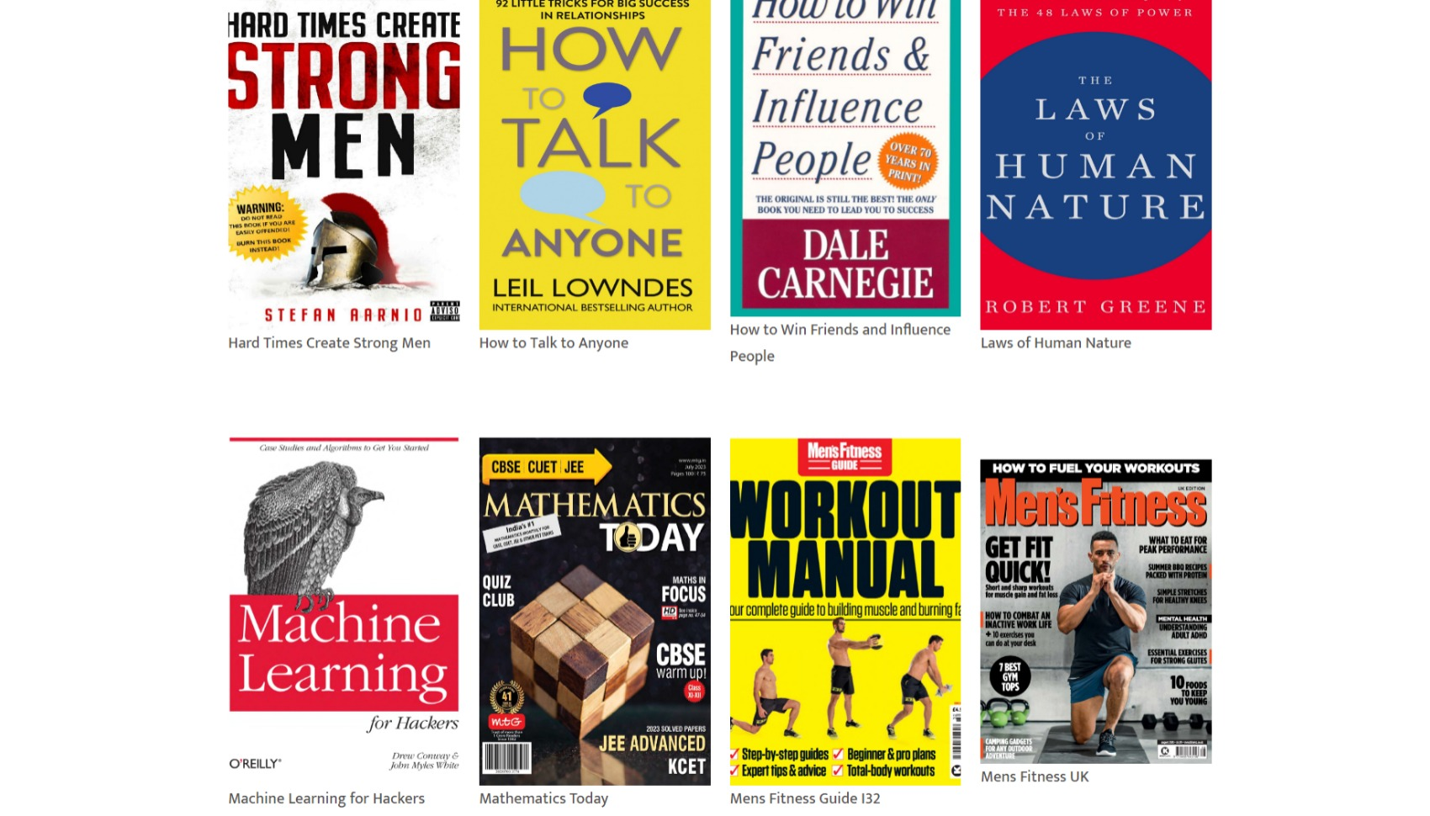

**Fig.11**

**List of books**

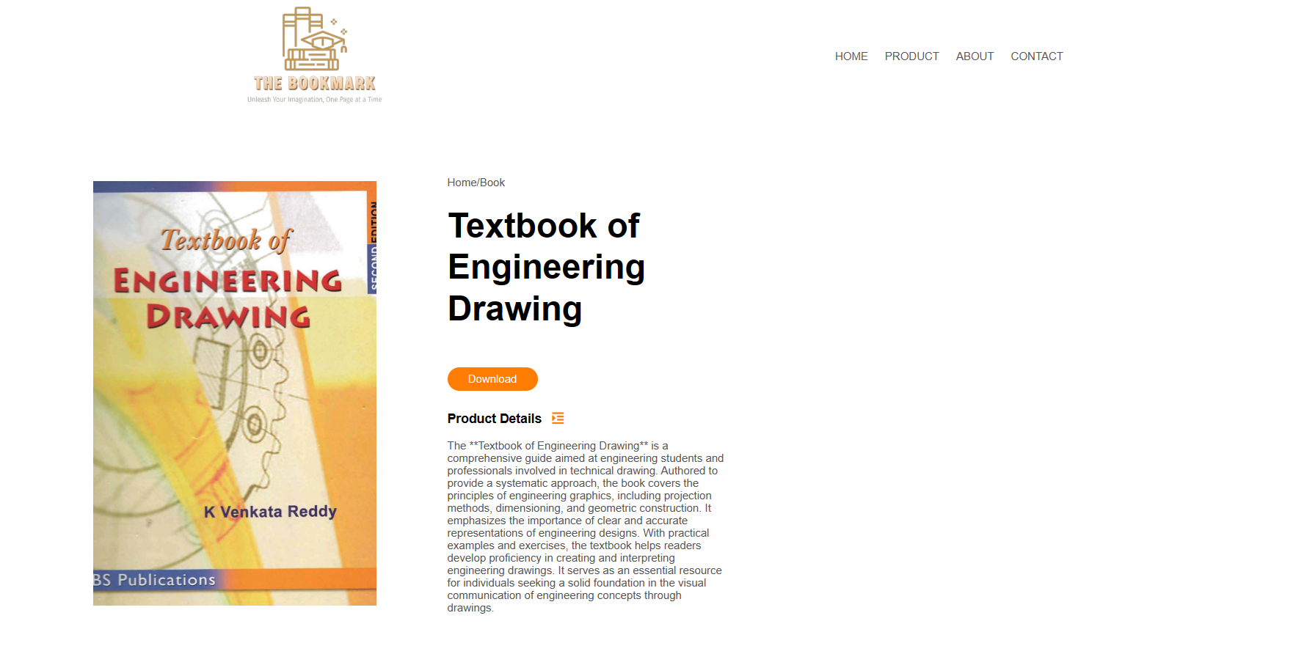

**Fig.12**

**Book Page**

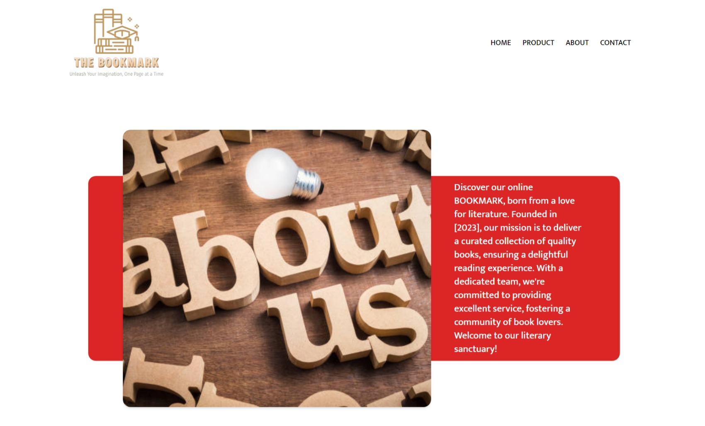

**Fig.13**

**About Us**

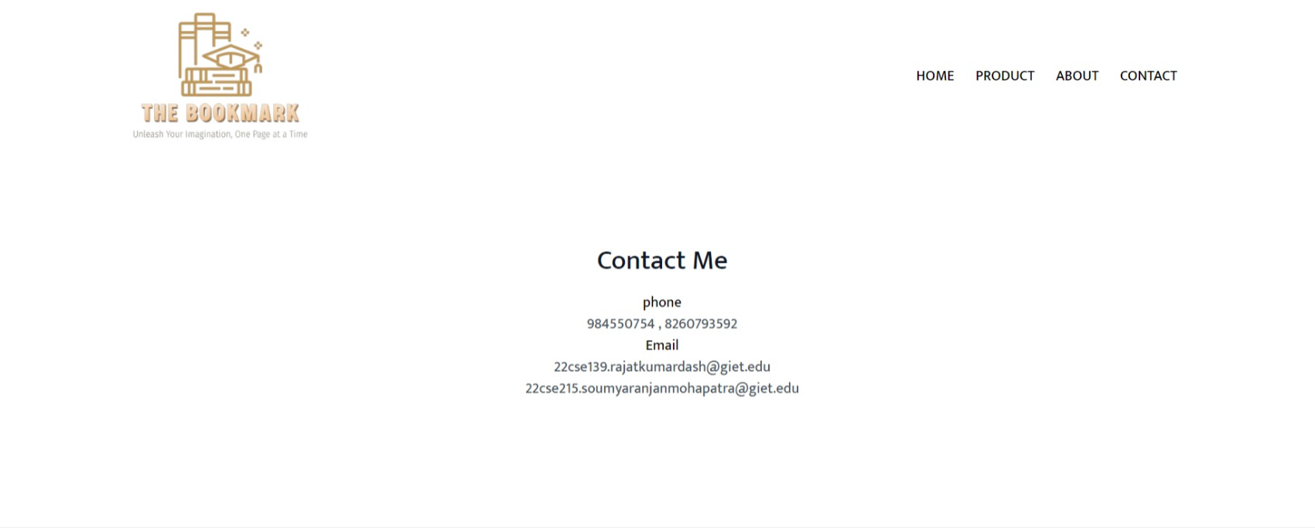

Fig.14

Contact Page

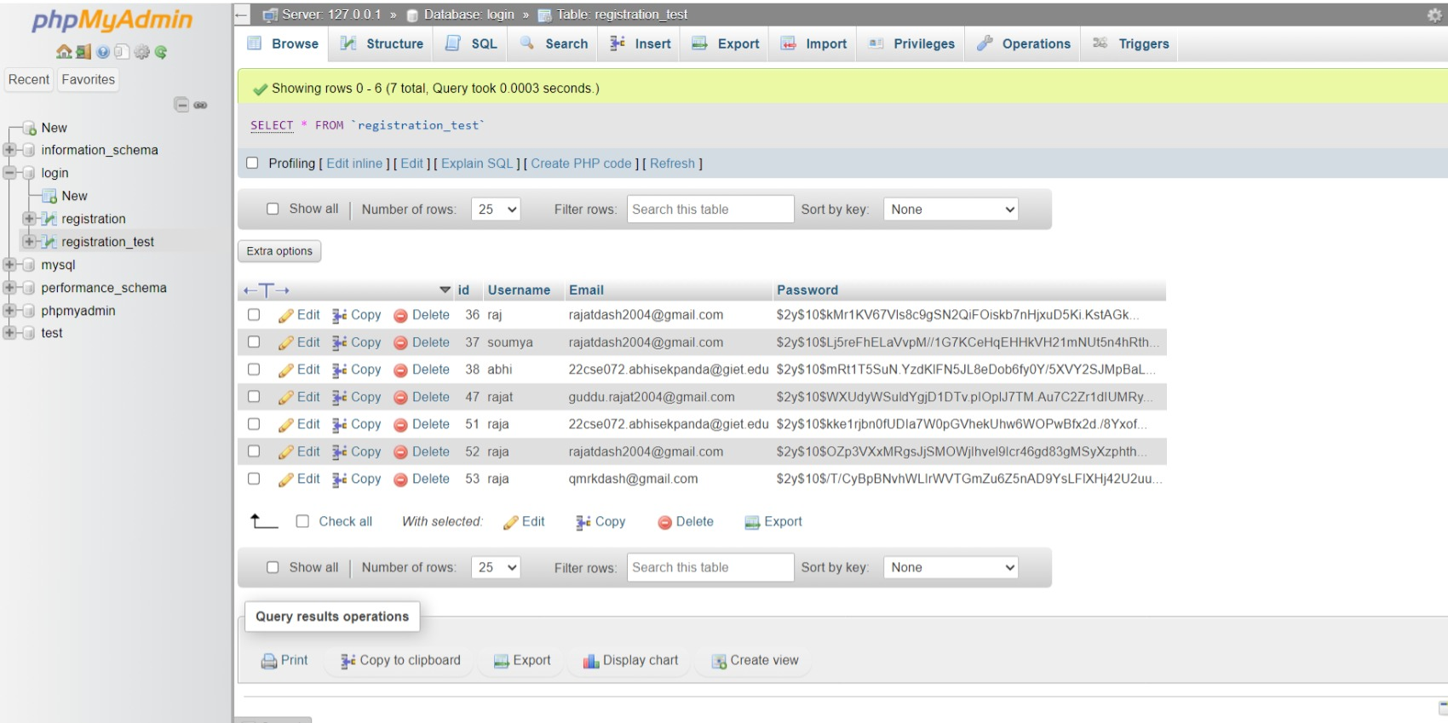

**Fig.11**

**Data Base**

**CHAPTER - 5**

**PROJECT CODING**

**5.1 User Login**

<?php

$servername="localhost";

$username="root";

$password="";

$dbname="login";

$conn=mysqli_connect($servername,$username,$password,$dbname);

if(!$conn){

echo "ERROR";

}

?>

<!DOCTYPE html>

<html lang="en">

<head>

<meta charset="UTF-8">

<meta http-equiv="X-UA-Compatible" content="IE=edge">

<meta name="viewport" content="width=device-width, initial-scale=1.0">

<title>Account</title>

<link rel="stylesheet" href="style.css">

</head>

<style>

@import url('https://fonts.googleapis.com/css2?family=Mukta:wght@300;500&display=swap');

body{

font-family: 'Mukta', sans-serif;

}

</style>

<body>

<div class="ac">

<div class="container">

<div class="navbar">

<div class="logo">

<img src="./resource/logo (2).png" alt="" width="200px">

</div>

</div>

</div>

</div>

<div class="account-page">

<div class="container">

<div class="row">

<div class="col-2">

<img src="./resource/bg.png" alt="">

</div>

<div class="col-2">

<div class="form-container">

<div class="form-btn">

<span onclick="Login()">Login</span>

<span onclick="register()">Register</span>

<hr id="Indicator">

</div>

<form id="LoginForm" action="login.php" method="post">

<input type="text" placeholder="Username_Log" name="Username_Log">

<input type="password" placeholder="Password_Log" name="Password_Log">

<button type="submit" class="btn">Login</button>

</form>

<form id="RegForm" action="register.php" method="post">

<input type="text" placeholder="Username" name="Username" required>

<input type="text" placeholder="Email" name="Email" required>

<input type="password" placeholder="Password" name="Password">

<button type="submit" class="btn">Register</button>

</form>

</div>

</div>

</div>

</div>

</div>

<div class="footer">

<div class="container">

<div class="row">

<div class="footer-col-1">

<h3>Download Our App</h3>

<p>Downlaod App for Android and ios mobile phone.</p>

<div class="app-logo">

<img src="./resource/play-store.png" alt="">

<img src="./resource/app-store.png" alt="">

</div>

</div>

<div class="footer-col-2">

<img src="./resource/logo (2).png" alt="">

<p>Our Purpose Is To Sustainably Make the Pleasure and Benifits of Sports Accessible to the many</p>

</div>

<div class="footer-col-3">

<h3>Useful Links</h3>

<ul>

<li>Coupons</li>

<li>Blog Post</li>

<li>Return Policy</li>

<li>Join Affilate</li>

</ul>

</div>

<div class="footer-col-4">

<h3>Folllow Us</h3>

<ul>

<li>FaceBook</li>

<li>Twitter</li>

<li>Instagram</li>

<li>Youtube</li>

</ul>

</div>

</div>

<hr>

<p class="copyright">Copyright 2023 - Rajat Creations</p>

</div>

</div>

<script src="index.js"></script>

</body>

</html>

**5.2 MAIN PAGE**

<!DOCTYPE php>

<php lang="en">

<head>

<meta charset="UTF-8">

<meta http-equiv="X-UA-Compatible" content="IE=edge">

<meta name="viewport" content="width=device-width, initial-scale=1.0">

<title>People Mart</title>

<link rel="stylesheet" href="style.css">

</head>

<body>

<!-- ---Header--- -->

<div class="header">

<div class="container">

<!-- ---Navbar--- -->

<div class="navbar">

<div class="logo">

<img src="./resource/logo (2).png" alt="" width="200px">

</div>

<div class="navbarin">

<nav>

<ul id="MenuItems">

<li><a href="main.php">HOME</a></li>

<li><a href="All_Products.php">PRODUCT</a></li>

<li><a href="about.php">ABOUT</a></li>

<li><a href="contact.php">CONTACT</a></li>

</ul>

</nav>

</div>

</div>

<div class="row">

<div class="col-2">

<img src="./resource/bg.png" alt="">

</div>

<div class="col-2 set">

<h1>Style yourself <br> with trending styles.</h1>

<p>A palce where style meets innovation. Find a different one in you.</p>

<a href="All_Products.php" class="btn">Explore Now &#8680;</a>

</div>

</div>

</div>

</div>

<!-- ---Featured Products--- -->

<div class="small-container">

<h2 class="tittle">Featured Products</h2>

<div class="row">

<div class="col-4">

<a href="Prod_det_1.php"><img src="resource\aa\A programmers guide to the mind.png" alt></a>

<a href="Prod_det_1.php">

<h4>A programmer`s guide to the

mind</h4>

</a>

</div>

<div class="col-4">

<a href="Product_det_4.php"><img src="resource\aa\Advance Penetration Testing.png" alt></a>

<a href="Product_det_4.php">

<h4>Advance Penetration Testing</h4>

</a>

</div>

<div class="col-4">

<a href="Product_det_3.php"><img src="resource\aa\Advance persistent thread hacking.png" alt></a>

<a href="Product_det_3.php">

<h4>Advance persistent thread

hacking</h4>

</a>

</div>

<div class="col-4">

<a href="Product_det_76.php"><img

src="resource\aa\How to Win Friends and Influence People - Dale Carnegie.png" alt></a>

<h4>How to Win Friends and Influence People</h4></a>

</div>

</div>

<!-- ---Latest Products--- -->

<h2 class="tittle">Latest Products</h2>

<div class="row">

<div class="col-4">

<a href="Product_det_10.php"><img src="resource\aa\Ethical Hacking.png" alt></a>

<a href="Product_det_10.php">

<h4>Ethical Hacking</h4>

</a>

</div>

<div class="col-4">

<a href="Product_det_24.php"><img src="resource\aa\12 Rules for Life.png" alt></a>

<h4>12 Rules for Life</h4></a>

</div>

<div class="col-4">

<a href="Product_det_18.php"><img src="resource\aa\Python Web Penetration Testing Cookbook.png"

alt></a>

<a href="Product_det_18.php">

<h4>Python Web Penetration

Testing Cookbook</h4>

</a>

</div>

<div class="col-4">

<a href="Product_det_55.php"><img src="resource\aa\Ego Is the Enemy - Ryan Holiday.png" alt></a>

<h4>Ego Is the Enemy</h4></a>

</div>

<div class="col-4">

<a href="Product_det_20.php"><img src="resource\aa\The Basics of Hacking and Penetration Testing.png"

alt></a>

<a href="Product_det_20.php">

<h4>The Basics of Hacking

and Penetration Testing</h4>

</a>

</div>

<div class="col-4">

<a href="Product_det_23.php"><img src="resource\aa\Textbook of Engineering Drawing.png" alt></a>

<a href="Product_det_23.php">

<h4>Textbook of

Engineering Drawing</h4>

</a>

</div>

<div class="col-4">

<a href="Product_det_9.php"><img src="resource\aa\Cant Hurt Me_ Master Your Mind and Defy the Odds.png"

alt></a>

<a href="Product_det_9.php">

<h4>CANT HUT ME</h4>

</a>

</div>

<div class="col-4">

<a href="Product_det_36.php"><img

src="resource\aa\Carnivore Code Cookbook_ Reclaim Your Health, Strength, and Vitality With 100_ Delicious Recipes, The - Paul Saladino.png"

alt></a>

<h4>Carnivore Code Cookbook</h4></a>

</div>

</div>

</div>

</div>

<!-- ---Exclusive--- -->

<div class="offers">

<div class="small-container">

<div class="row">

<div class="col-2">

<img src="./resource/exclusive.png" alt="" class="offer-image">

</div>

<div class="col-2">

<p>Exclusive On The Bookmark.</p>

<h1>Life of a Candle</h1>

<small>

This is a limited period offer. Grab a great companion for your journey now. "Life of a Candle"

is a captivating literary journey that takes readers on an intimate exploration of an everyday

object that holds profound symbolism. Written by an eloquent author.

</small>

<a href="" class="btn">Coming Soon ⇨</a>

</div>

</div>

</div>

</div>

<!-- ---Testimonial--- -->

<div class="testimonial">

<div class="small-container">

<div class="row">

<div class="col-3">

<i class="fa fa-quote-left"></i>

<p>One of the most popular names that almost everybody knows who reads books. <i>Stephen King </i>is

an American fiction writer. His books mostly belong to genres like horror, supernatural, and

crime. Stephen King is now in his 70s and has spent his life writing best-selling books that are

popular all over the world.</p>

<img src="./resource/test2.png" alt="">

<h3>Joanne Rowling</h3>

</div>

<div class="col-3">

<i class="fa fa-quote-left"></i>

<p><i>Robert Kiyosaki</i> has challenged and changed the way tens of millions of people around the

world think about money. He is an entrepreneur, educator, and investor who believes the world

needs more entrepreneurs who will create jobs.</p>

<img src="./resource/tezt3.png" alt="">

<h3>Robert Kiyosaki</h3>

</div>

</div>

</div>

</div>

<div class="brands">

<div class="small-container">

<div class="row">

<div class="col-5">

<img src="./resource/Bookorg.png " alt="">

</div>

<div class="col-5">

<img src="./resource/B0.png" alt="">

</div>

<div class="col-5">

<img src="./resource/B31.png" alt="">

</div>

</div>

</div>

</div>

<div class="footer">

<div class="container">

<div class="row">

<div class="footer-col-1">

<h3>Download Our App</h3>

<p>Downlaod App for Android and ios mobile phone.</p>

<div class="app-logo">

<img src="./resource/play-store.png" alt="">

<img src="./resource/app-store.png" alt="">

</div>

</div>

<div class="footer-col-2">

<img src="./resource/logo (2).png" alt="">

<p>Our Purpose Is To Sustainably Make the Pleasure and Benifits of Sports Accessible to the many</p>

</div>

<div class="footer-col-3">

<h3>Useful Links</h3>

<ul>

<li>Coupons</li>

<li>Blog Post</li>

<li>Return Policy</li>

<li>Join Affilate</li>

</ul>

</div>

<div class="footer-col-4">

<h3>Folllow Us</h3>

<ul>

<li>FaceBook</li>

<li>Twitter</li>

<li>Instagram</li>

<li>Youtube</li>

</ul>

</div>

</div>

<hr>

<p class="copyright">Copyright 2023 - Rajat Creations</p>

</div>

</div>

</body>

</php>

**CHAPTER – 6**

**TESTING**

**1.Functional Testing:**

**.Book Download Functionality:**

.Verify that users can successfully download books.

.Test different scenarios, such as authorized and unauthorized users attempting to download.

**2. User Interface (UI) Testing:**

**.Layout and Responsiveness:**

. Ensure the UI is visually consistent and responsive across various devices and screen sizes.

**.Interactive Elements:**

. Test any interactive elements, such as buttons or links, to ensure they function as expected.

**3. Security Testing:**

**Authorization Checks:**

Confirm that the download functionality includes proper authorization checks to prevent unauthorized access.

**Data Security:**

Ensure that user data, especially sensitive information, is handled securely

**4. Compatibility Testing:**

**.Browser Compatibility:**

Test the application on different web browsers to ensure compatibility.

**.Device Compatibility:**

Verify that the application works well on various devices, including laptops, tablets, and smartphones.

**5. Usability Testing:**

**.User Journey:**

Evaluate the user journey from accessing the site to downloading a book, ensuring it is intuitive and straightforward.

**Clarity of Instructions:**

Check that instructions for downloading are clear and easily understandable.

**6. Accessibility Testing:**

**.Screen Reader Compatibility:**

Check if the application is accessible to users with disabilities, including compatibility with screen readers.

**7. Load Testing:**

**Simulate Traffic:**

Test the application under high traffic conditions to ensure it can handle multiple concurrent users downloading books.

**CONCLUSION**

In conclusion, "The BOOKMARK" project, a user-friendly online book store, prioritizes simplicity and accessibility, offering a seamless experience for users to explore and download books. The project's core functionalities, implemented using HTML, CSS, JavaScript, and PHP, focus on presenting book details and facilitating downloads without unnecessary complexities like search, ratings, or feedback. The project ensures a visually appealing and responsive design, enhancing the user interface with dynamic elements.

Functional testing validates the reliability of the book download process, ensuring users can seamlessly access literary content. UI testing guarantees a visually consistent and responsive layout, while security testing emphasizes authorization checks and secure handling of user data. Compatibility testing ensures the project works across browsers and devices, promoting widespread accessibility. Usability testing evaluates the user journey and the clarity of instructions, prioritizing a straightforward and intuitive experience.

Data integrity testing confirms the accuracy of book information, fostering trust in the displayed details. These testing aspects collectively contribute to a robust and user-centric application. The conclusion underscores the project's commitment to simplicity, security, and reliability, providing a valuable platform for users to engage with literature effortlessly. As "The BOOKMARK" project evolves, ongoing testing and user feedback will be essential for continuous improvement and the enhancement of user satisfaction.

**LIMITATIONS**:

**1.Feature Limitation:**

- The intentional simplicity of the project, while promoting a streamlined user experience, also results in the absence of advanced features such as search functionality, user ratings, and feedback. Users are limited to basic book display and download capabilities, potentially reducing the ovrichness of the user experience

**2.Personalization Absence:**

- The lack of user accounts and personalized profiles means that the project doesn't offer features tailored to individual preferences. Users miss out on personalized book recommendations, reading history tracking, and the ability to customize their interactions with the platform.

**3.Security Constraints:**

- While security measures are in place, the project may have limitations in terms of advanced security features. This could include the absence of end-to-end encryption for stored user data, potentially posing concerns regarding comprehensive data protection.

**4. Scalability Challenges:**

- As the project expands, there might be challenges related to scalability. A significant increase in user traffic or a growing book catalog could impact the application's performance, potentially leading to slower response times or other scalability issues.

**5. Dependency on Server Availability:**

- Users are dependent on the server's availability for accessing the download functionality. Any server downtime or maintenance could temporarily disrupt users' ability to download books, highlighting a limitation in terms of continuous, uninterrupted service.

**6.Potential Copyright Concerns:**

Without a clear system for verifying the legality of uploaded books or the assurance of copyright compliance, there may be potential legal and ethical concerns regarding the content available for download.

**7.Accessibility Challenges:**

While efforts are made to ensure compatibility, there may still be challenges in achieving optimal accessibility for users with disabilities, particularly without specific accessibility features.

**REFERENCES**

1.Footer - https://www.altcademy.com/blog/how-to-make-a-footer-in-html

2.NavBar - https://www.w3schools.com/css/css_navbar.asp

3.MySQL - https://www.w3schools.com/php/php_mysql_connect.asp

4.Login - <https://codemyui.com/tag/login-form/>

5.Books download page - <https://manybooks.net/>

6.CSS - <https://freefrontend.com/css-hover-effects/>

7.html - <https://www.w3schools.com/html/>

8.Database - <https://www.w3schools.com/html/>